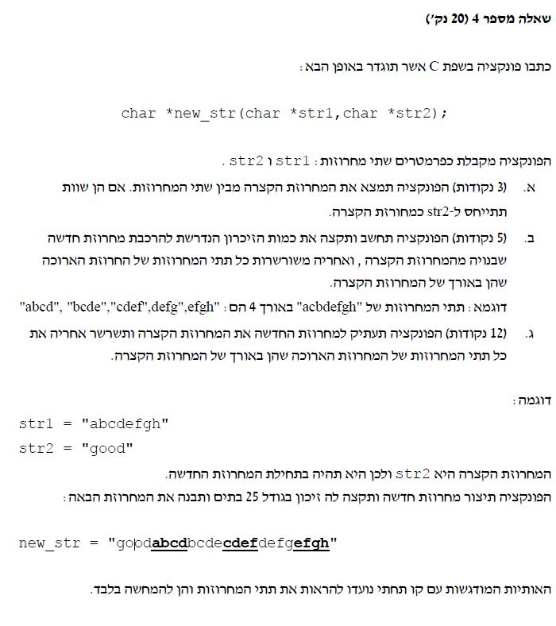

#include <stdio.h>

#include <string.h>

#include <ctype.h>

#include <stdlib.h>

// Answer 4:

// OUTPUT: New str3 is "goodabcdbcdecdefdefgefgh"

// Will add the shorter str first, and the str1 in len of str2 in str3

char *new_str(char *str1, char *str2) {

int len1, len2,len3=0, times=0;

char *str3=NULL;

len1 = strlen(str1);

len2 = strlen(str2);

if (len1 > len2)

{

times = (len1 - len2) + 1;

len3 = len2 + (len1 - len2 + 1)*len2;

str3 = (char*)malloc(len3 * sizeof(char)); //Dynamic allocation

strcpy(str3, str2);

while (times) {

strncat(str3, str1, 4);

str1++;

times--;

}

}

return str3;

}

int main()

{

char str1[] = "abcdefgh", str2[] = "good",*str3=NULL;

str3 = new_str(str1, str2);

printf("New str3 is: %s\n", str3);

getchar();

return 0;

}